**APCSP Activity 1.3.1: Register Instructions**

Learning Target: Generate and organize information in order to communicate observations, processes, and results.

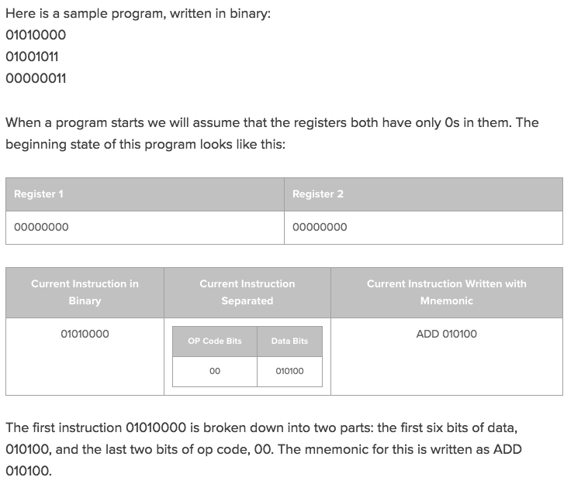

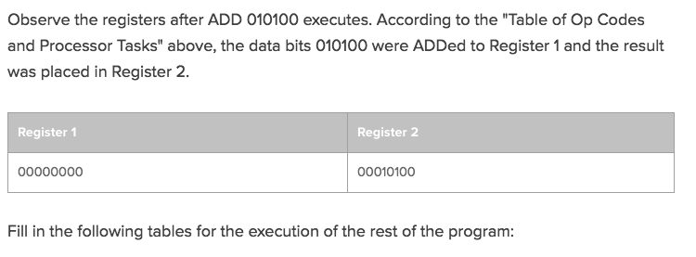

**Instruction 2**

|  |  |  |
| --- | --- | --- |
| **Current Instruction in Binary** | **Current Instruction Separated** | **Current Instruction Written with Mnemonic** |
| 01001011 | |  |  | | --- | --- | | OP Code Bits | Data Bits | | 11 | 010010 | |  |

**Registers After Instruction 2**

|  |  |
| --- | --- |
| **Register 1** | **Register 2** |
|  |  |

**Instruction 3**

|  |  |  |
| --- | --- | --- |
| **Current Instruction in Binary** | **Current Instruction Separated** | **Current Instruction Written with Mnemonic** |
| 00000011 | |  |  | | --- | --- | | OP Code Bits | Data Bits | | 11 | 000000 | |  |

**Registers After Instruction 3**

|  |  |
| --- | --- |
| **Register 1** | **Register 2** |
|  |  |